Goal:

* Science: rivers are drying up and that changes the ecology. We want to know where rivers are drying up or wetting up. Hydrologic conductivity and groundwater processes can be inferred.
* Can we observe discharge in these areas? Want to know which rivers are drying and wetting when
* We have the model that we use as ground truth
* Then if we try to do this map with drones and satellites it will look different
* Observe with satellites (VNIR) during day, trigger UAV observations (IR) at night based on satellite observations
* The delta btw observations and ground truth would be a figure of merit
* Areas: Mississippi river delta (1000-km extent)? Actually West Texas

Agents:

* Landsat (15m/30m/100m resolution sufficient?, required is 5m?), Sentinel 2, Planet Skysat (VNIR) offers 50cm resolution + N UAVs? VNIR, maybe SWIR, or TIR. Probably not SAR, perhaps lidar. Observations need to be made at local daylight conditions (can be inferred by the InstruPy’s SNR calculation).

3d-chess comms:

3d-chess conops/mission profile:

* Satellites are tasked to observe the W.Texas area.

*Satellite observation tasking (reward function)*

* + The swath of Planet Skysat is only 20km. Multiple Skysat observations need to be made per day to observe the entire area. Landsat 8/9 have low revisit (9 days?). Daily observations of the area are not possible with Landsat alone.
  + Since instruments are VNIR, satellite observations are made when there is daylight.
  + Grid the area of interest (with the stream vertices?). Plan for the satellites to cover 100% of the area. After 100% is reached then stop covering the area. If 100% is not reached within the day, consider the area to be (part) observed for that day.
  + UAVs are triggered at *night time* based on *current day's* satellite data.
  + Reward function should also try to have the satellites *not* miss out on observing parts of an area consistently. This can be done by maintaining history of observations of GPs over consecutive days, and prioritizing GPs which are being consistently missed out.

*Satellite model*

* + Same as that in Scenarios #1 & #2

*Satellite observation synthesis*

* + Use a science model to produce fake *and processed (i.e. stream-widths)* satellite observations. Here the science model data is treated as the truth.
  + The processed satellite data is used to dictate observation priorities, i.e. sci value of streams to be observed.
* UAVs are then tasked to observe prioritized areas based on satellite VNIR observation data

*Reward function*

* + Compute rewards to observe per stream, using the current day's data. Only those streams which have been observed the current day should be considered.
    - Need to build mapping between GPs and streams.
  + Reward (of a stream)
    - x = |w(k) - w(m)|, where k is the current day. m is the latest day prior to the k day for which the observation of the stream is available, i.e. m<= k-1
    - Prioritize stream drying over stream wetting
    - tie in other information like proximity to oil wells or population centers, or some sort of ecological value.

*UAV model*

* + Max flight time, Max payload operation time ~ proxies for UAV power. Represent hard constraints.
  + UAV speeds & associated time-costs
    - Acceleration (acc) and max UAV speed (vmax) is used to calculate time flight between two streams
    - Scan speed (vscan) is used to calculate the time to image. It depends on the instrument too. Assuming line scanner (pushbroom), the exposure time to the detectors needs to be considered.
  + UAV base-station (charging)
    - UAV shall need to go back to base-station periodically before maxing out its flight or imaging time. And recharge for time tcharge and return to operations.
    - It need not be that the flight/imaging time needs to be nearly maxed out before going for charging. It could be more optimal to go back with more than 50% charge, because the UAV happens to be near the base station.
  + Operation time per stream: Depends on vscan and length of streams. Consider stream sinuosity?
  + *Planning:* Come out with a sequence of streams to be observed, interlaid with charging times (flights back to base-station) per day. Maximize the cumulative sum of the reward (of a stream).
  + Operations from 6pm to 8am local time (i.e. outside nominal daylight hours) when satellites shall be making observations.
    - Variations can be considered, i.e. 24 hr operations. No reason to limit it to outside daylight hours. But it makes it simpler to separate the satellite/UAV observation time-domains.

Science models

* Hydrological model ( to produce artificial processed satellite data ). Output is a time (daily) series of stream width predictions at West Texas region (Pecos river?, a non-perennial river).

Sim Parameters:

Metrics:

* Number of streams monitored by satellites, UAVS
* Statistics of the cumulative reward term (satellite, UAV) per day which quantifies the ‘amount’ of dying/ wetting observed.
  + Normalize to the best case scenario (i.e. all the area is observed with both satellites & UAVs everyday of the year). See all the streams which have undergone changes.

Variables:

* # UAVs, UAV parameters

Results:

Near-term tasks:

* ~~Mathematical definition of the simple UAV model (time costs)~~
* ~~Mathematical definition of the satellite and UAV planner reward functions~~
  + ~~Grid generation for satellite coverage~~
* Integration of the satellite reward function into the planner
* Integration of the UAV model & reward functions into the planner

**Domain**

* Pecos river network.
* There are in total 2948 streams.
* Each stream Si is characterized by a series of vertices.

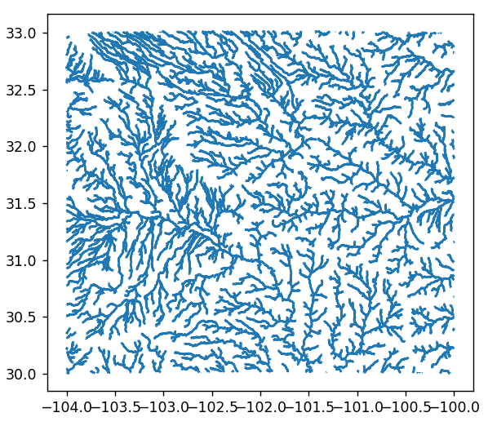

**UAV model**

1 charging point (base-station). Setup at the middle of the domain. Call it ‘B’.

Position of B is (31.5 deg lat, -102 deg lon)

*Constraints*

* Max flight time of UAV = Tf =6 hrs (not realistic with COTS drones)

*UAV parameters*

* Charging time for 100% charge = 30 mins
* Max velocity of UAV = vmax = 5m/s
* (De) Acceleration = ac = 2m/s2
* Scan velocity (i.e. the speed during imaging) = vscan = vmax  (simplification)

*Flight Model*

Distance between two positions (lat, lon coords) is given by the great-circle distance as given here: <https://en.wikipedia.org/wiki/Great-circle_distance>

Possible flight paths are and corresponding **time-costs:**

* **B -> Si:** Base station to the **first** Vertex of Stream Si

Let the distance to be covered be ‘d’. Start of with initial velocity = 0 and end velocity = vmax

Two cases:

>> Distance from base-station to Si is less than the time required to achieve vmax

The UAV shall execute a longer route to achieve the max speed.

If $d <=d'={{1/2 v}_{max}}^{2}/a_{c}$, then $t=t' = v_{max}/a_{c}$

>> Else $t=v_{max}/a_{c} +(d - d')/v_{max}$

* **Si -> Sj :** **Last** Vertex of stream Si to the **First** Vertex of Stream Sj

Start and end velocities = vmax

Hence, $t=v_{max}/a_{c}$

* **Si -> B:** **Last** Vertex of stream Si to the Base Station

Start velocity = vmax and end velocity = 0

>> Distance from base-station to Si is less than the time required to achieve vmax

If $d <=d'={{1/2 v}_{max}}^{2}/a_{c}$, then $t={t' = v}_{max}/a_{c}$

>> Else $t=v_{max}/a_{c} +(d - d')/v_{max}$

* **Scan stream Si:**

, where Li is the ‘length’ of Si (which is unchanging)

**Reward Functions**

*Satellite reward function*

The satellites (together) prioritize 100% coverage of the domain. The domain is populated with grid-points (= first Vertex of the streams). After reaching 100% the reward is 0.

Observations need to be taken from 10:00 am to 4pm local time

Thus we define the reward for Stream Si on current day ‘k’ as:

$r_{i}(k) =1 +j_{}^{}$

where ‘j’ is the number of consecutive days (prior to k) there have been no-observations of the Stream Si

*UAV reward function*

The UAV prioritizes change in stream widths (drying is prioritized) triggered by the current-days satellite observation.

Observations need to be taken from 9:00 pm to 10:00 am local time

* Allow for sufficient time to downlink satellite data and do processing

Reward from imaging Stream Si on day k

$r_{i}(k) =f |w(k) - w(m)|$,

$f=1$ if $w(k) <$ $w(m)$, else $f=0.5$ (Stream drying is prioritized)

where,

‘k’ is the current day,

‘m’ is the day prior to k day for which the observation of the stream is available, i.e. m<= k-1

*Files*

**river_info.csv**

Columns

* 1st column: No header, stream index
* 2nd column: first vertex (lon, lat) of the stream
* 3rd column: last vertex (lon, lat) of the stream
* 4th column onwards: w1, w2, ….., w365 Widths of the streams in meters

*References*

Nagasawa, R., Mas, E., Moya, L. et al. Model-based analysis of multi-UAV path planning for surveying postdisaster building damage. Sci Rep 11, 18588 (2021). (However the flight model i.e. equation 9 appears to be wrong!)

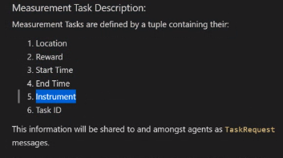

<https://github.com/seakers/DMASpy>

<https://github.com/seakers/DMASpy/tree/sim_restructure_dev>

Things to study: